Bristol & Gloucestershire Archaeological Society
Bristol Section talk by Gail Boyle, FMA, FSA,
Senior Curator, Bristol Museum and Art Gallery
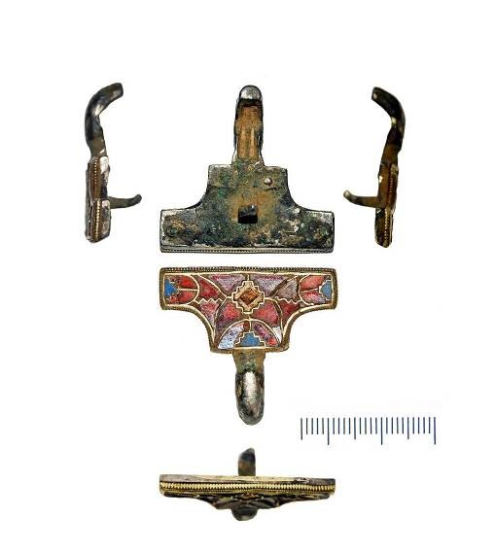

“Treasure: All that glisters is not gold”
The treasure process and the issues it poses to museums and finders. Illustrated throughout by images of recent finds from the Bristol & Gloucestershire area

Monday 27th September 2021 at 7.45 pm
The Apostle Room, Clifton Cathedral, Pembroke Road, Bristol BS8 3BX
Off-street parking available; 8 and 9 buses run nearby
Maximum number of attendees 30

